9.94: a) From the parallel-axis theorem, the moment of inertia is

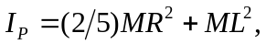and

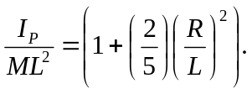

If R = (0.05)L, the difference is which is 0.33% when 